1. donwloaded 64bit mysql server(only 40 mb). installed the same.

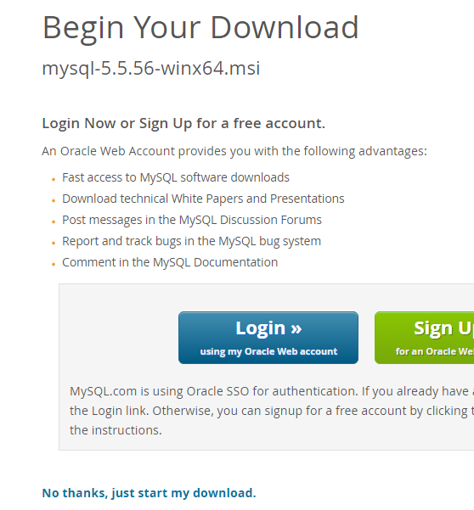

configured the server to run on 3906 port number.

1. downloaded connectorj driver which is provided by mysql itself.

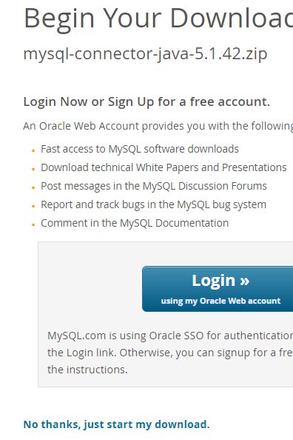

3. started mysql command line and created db the used the db then create

table inside db and inserted value in table.

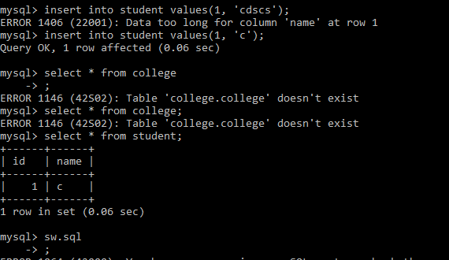

4. then added connectorj mysql jar in project.

In intelij use ctlr+shift+alt+s to add external library.

Step-1.

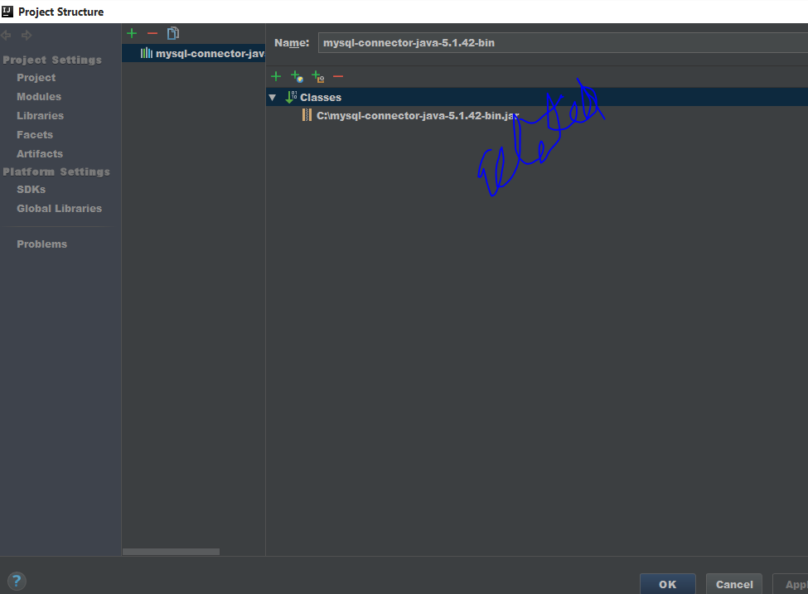

Step-2

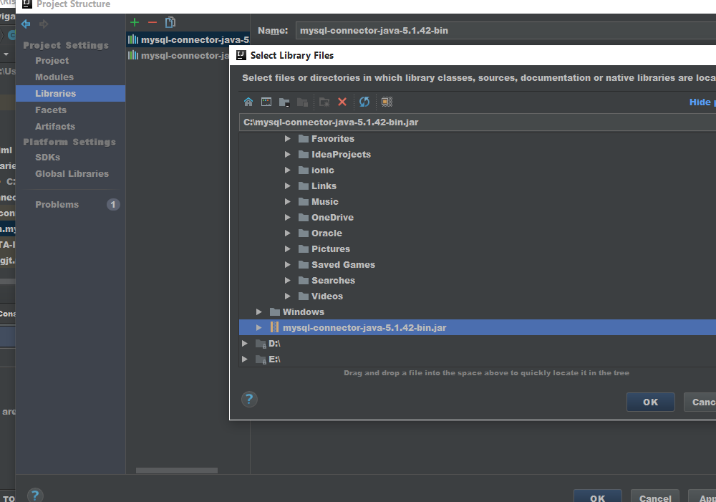

5. and got the code from javatpoint.

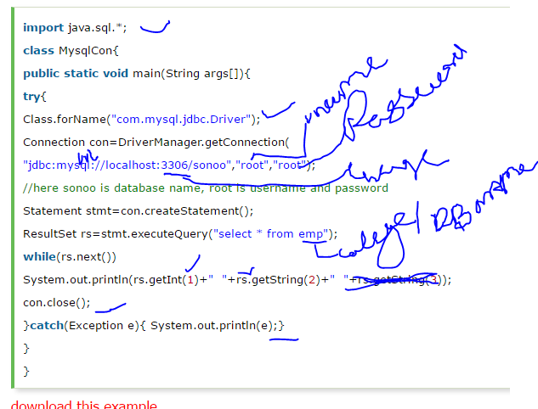

Real code->

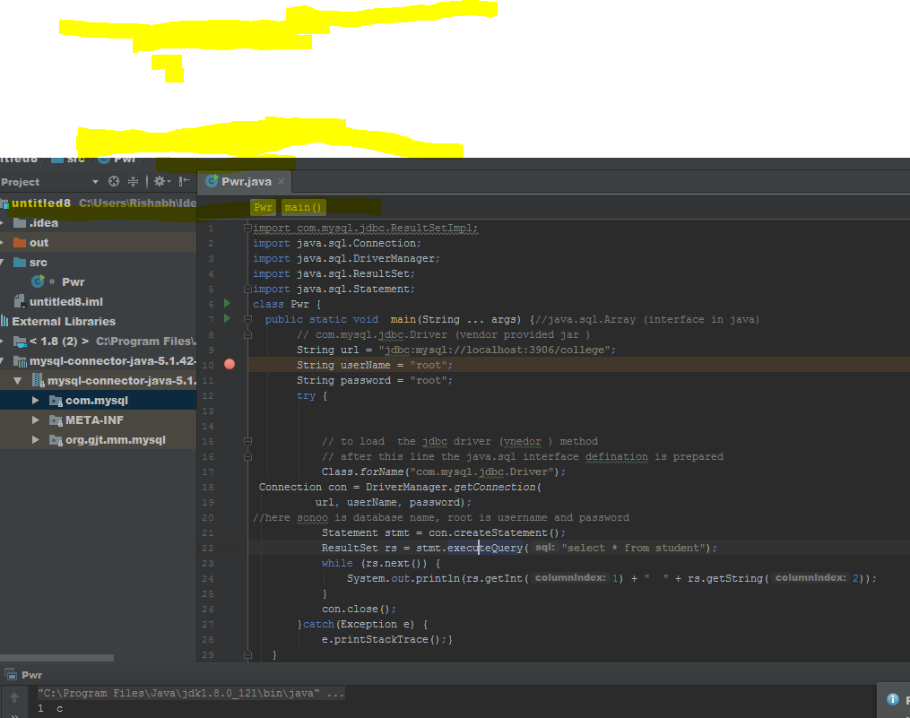

6. changed the configuration inside code according to our connection.

7. run the code.